**Project Management Assessments Check List**

# Contents

Contents 0

Overall: 0

Assessment Cover Sheet 0

Assessment one 0

Assessment two 1

Learning Notes 1

Web support 1

Search Index 4

# Overall:

* Submission last date is: 10/05/2024. Wish submit on or before 12/05/2024
* Assessment file name and cover sheet must start your id (replace XXXXX by your id)
* Assessment name and id must be clear indicate on the top (after cover page)
* Assessment cove, table contents and search index could be found on your assessments.
* Show the web link and easy to access could be got more marks.
* QR access by the phone will let you get more marks.
* You are web project address, need contain your id.
* You have to submission two assessments with cove sheet by your signature.

# Assessment Cover Sheet

* Signature, Name and Id should be clear indicated.
* Cover sheet name using the template name with your 5-student id digits to start.
* Submission to right place on the Moodle.

# Assessment one

* Assessment cover looks good.
* Your web link should be indicated clearly. Please using yellow colour to highlight.
* Project case could be any title but be reasonable!
* Gant char using Google sheet is a good option. Refer the sample project.
* The Google sheet need set to share edit by everyone. So, it will be easy to access.
* Need your screen shot for your Gant Project diagram.
* Publish by html will help you get more marks.
* Web support index page should show download on your assessment’s links.
* Project sign-off sheet, evaluation check list and lessons learned could be download any image from Google or design your google sheet.

# Assessment two

* Assessment cover looks good.
* The yellow colour to select from multiple choice are provided.
* All multiple select questions need your support words, relevant image, web reference and your comment.
* Please using yellow colour to highlight your comments.

# Learning Notes (optional)

* Follow the video about project basic concept, need you provide your learning notes.
* These should be clear indicate your watched and understood about project basics.
* Two or three pages may be enough. Please refer the sample project.
* Your learning notes could be following your assessment two.
* <https://www.youtube.com/watch?v=rBSCvPYGnTc&t=1323s>

# Web support

* Anyone could be viewed your support web site.
* Your id number should be show on the top left, replace 12345 by yours.
* Project footer section should be with your full name and your student id.
* All the page links should be working and redirect to new tab.
* If you could provide the project topics from yours, it will be great!
* Good web site will get much more extra marks.
* QR diagram should be on your index page, so your site could be visited by mobile phone!
* Download assessments should be working.
* Gant char solution should be linked on the web browser.
* Need favour icon show on your browser tab with your name first letter.
* Example: <https://wellsjohn220.github.io/pmdemo>
* You are web project address, need contain your id.

# Challenge Task

Show your contact details by data read:

<https://wellsjohn220.github.io/pmt32023by12345/#services>

Here is part of web project output sample:

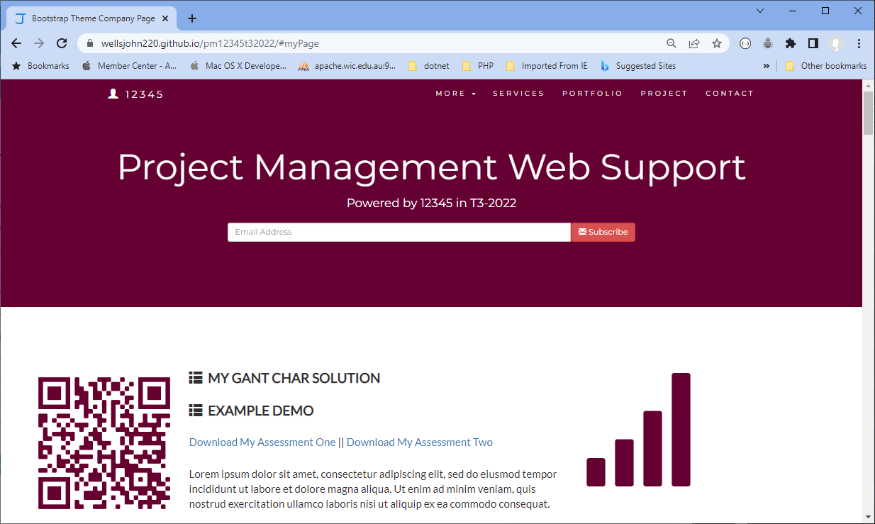

or

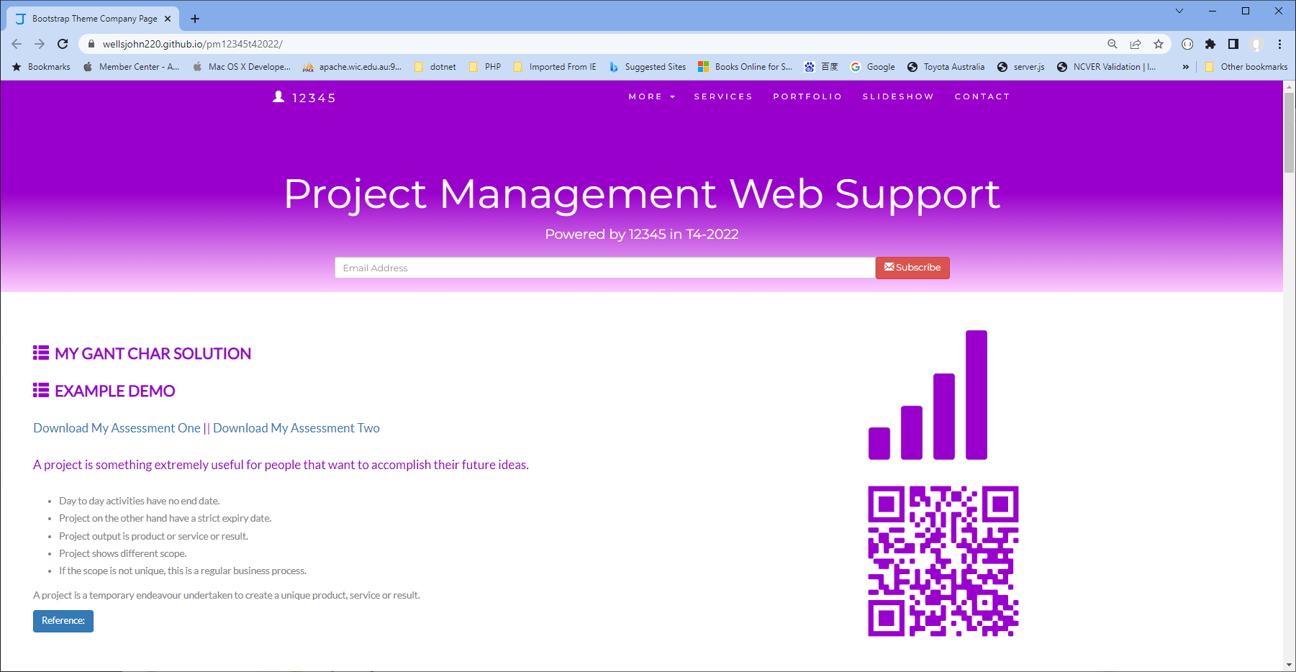

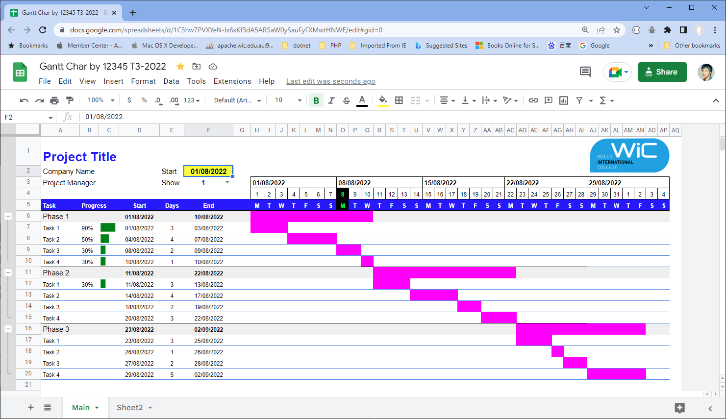

Or

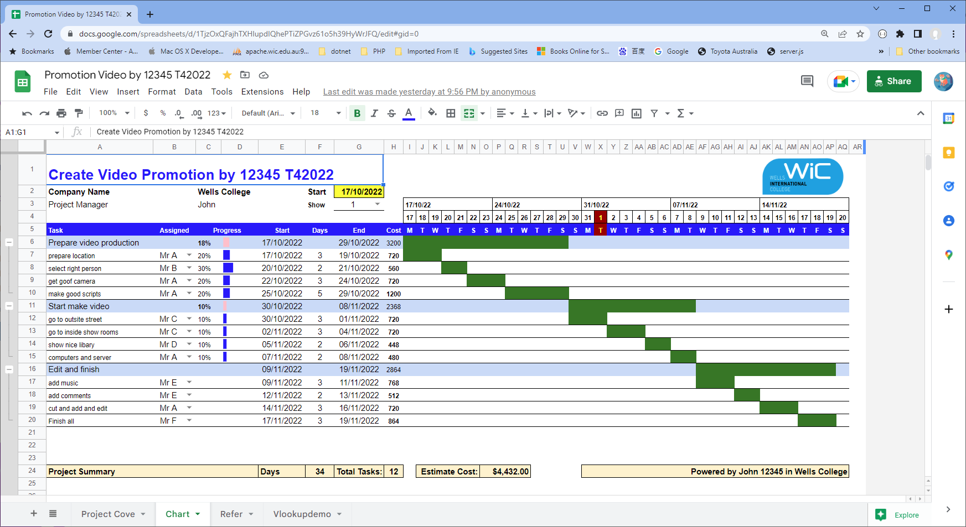

Please note above task and you could add any topic! The link could be access by your web project.

# Search Index

# 

B

browser 2

D

Download 2

G

Gant char 1

Gant Project 1

P

project basic 2

Q

QR access 1

S

Signature 1

student id 1

Submission 1